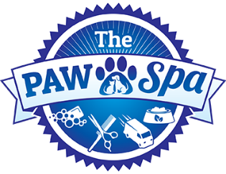

Hello friends - we hope you and your families have all been well during this crisis. We finally have some good news on the horizon! We are planning our soft re-opening for Friday May 1rst. By soft, we mean very limited appointments with STRICT guidelines we will be following in order to maintain the safety of our staff, our customers and your pets.
PLEASE READ IMPORTANT NEW GUIDELINES FOR CHECK-IN :
- We are only accepting existing customers for grooming that have made an appointment in advance. At this time we are not accepting any walk ins, email requests or Facebook text messages for appointments, you must call (951-371-2250).
- When you arrive please limit those that get out of your vehicles to 1 guest. We are limiting our staff members inside as well.
- You must be wearing some sort of face covering (mask). Our showroom staff will be as well.
- Please wait outside (maintaining social distancing rules / 6ft apart) until you're asked in.
- Pets can be brought in thru our front door (one person at a time) and you will be met at the front by one of our staff to check you in. For now, you will be unable to walk the aisle’s in our store. If you would also like pet food you can place your order at the front, call in for pick up later, or online using our Home Delivery Service. (https://www.coronapawspa.com/home-delivery)

- At check in you will be asked to remove all collars, leashes, bandana's etc... We will have our own leads (leashes) to check in your pets.
- As much as we'd love to get everyone in the first day, it simply won't be possible. We ask for your patience as we learn to best navigate this unprecedented time. This also means we may alter or change policies to further improve how we serve you, while also maintaining the safest possible measures for our staff and you.
- We can respect those that are still reluctant to venture out - we hope to see you back soon. Ours and your safety is a top priority for us, but we also want to note that those that are unable to follow the above guidelines, may be refused service.
We also want to extend a personal thank you to all our customers that supported us with their online pet food orders (coronapawspa.com) and messages of support !

We are excited to be back !
The Paw Spa

